# **PeopleSafe - Pay Your Balance Alert**

Background

Frequently Asked Questions and Answers

Related Document

**Description:** An email alert designed to inform members when they have an outstanding balance on their account. This is not a collections email. It is intended to proactively help members prevent future order delays that could be caused if their balance exceeds client-set limits.

|  |
| --- |
| Background |

Pay Your Balance Alerts are sent to members who have filled a prescription through the Home Delivery pharmacy and have an outstanding account balance 14 days after the order was shipped.

* If a balance remains, a reminder email will be sent **seven** days after the original email and a second reminder can be sent after seven more days.

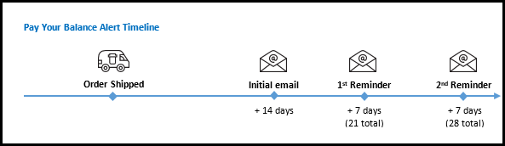

* The emails provide members with a link to Caremark.com where they can pay their outstanding balance. If a member calls about the alert, refer to Frequently Asked Questions and Answers.
* **Initial Pay Your Balance email** (14 days after order shipment):

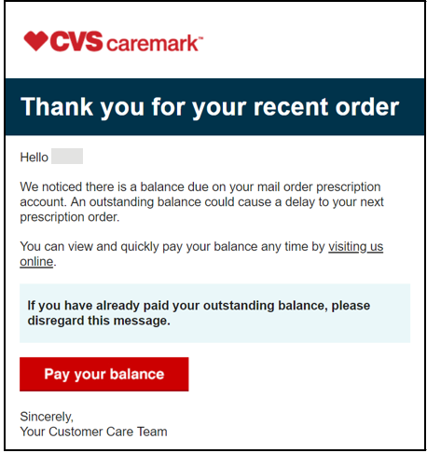

* **First Reminder** (7 days after initial email; 21 days after order shipment):

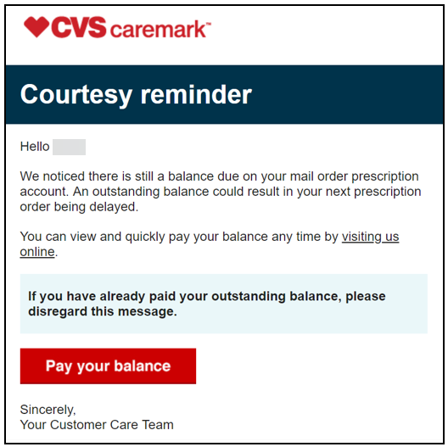

* **Second Reminder** (7 days after 1st Reminder email; 28 days after order shipment):

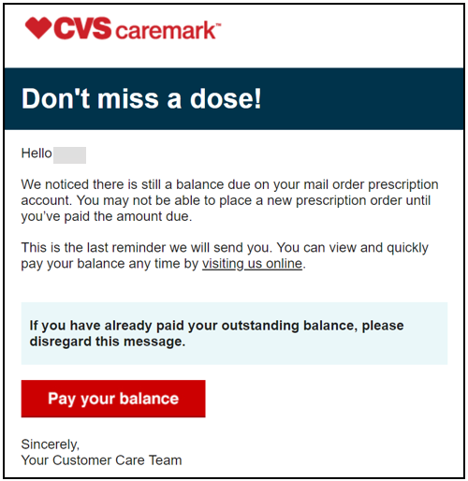

Top of the Document

|  |
| --- |
| Frequently Asked Questions and Answers |

Use as needed:

|  |  |
| --- | --- |
| **Question** | **Possible Answer** |
| Why did you send me this email? | The email is sent to members who have a balance on their account 14 business days after a mail order prescription was shipped. The email is meant to be a reminder and provides an easy way for you to pay your balance online. |
| Is this a collections email? | No. This email is meant to be a reminder and provides an easy way for you to pay your balance online. |
| I do not want these emails. Can you stop them? | Yes. I can turn off the Pay Your Balance reminder emails.  **To turn off the email alert:**   1. From the Main Screen of PeopleSafe, go to **Change Contact Info.** 2. In Messaging Preferences under Programs, find the program **Payment Notifications**. 3. Uncheck the box for Email. 4. Click **Update Program**. |
| Can I still pay by phone or by check? | Yes. You can continue to pay in your preferred method. This email alert provides you with an additional option to pay. |
| I sent a check. Have you received it yet? | Review member’s account and provide appropriate answer.  It is likely that the check is still in the mail or has been received but not yet processed. Member can review caremark.com to determine when the payment is applied. |

Top of the Document

|  |
| --- |
| Related Document |

[Customer Care Abbreviations, Definitions and Terms Index (017428)](https://thesource.cvshealth.com/nuxeo/thesource/#!/view?docid=c1f1028b-e42c-4b4f-a4cf-cc0b42c91606)

Top of the Document

Not to be Reproduced or Disclosed to Others without Prior Written Approval

**ELECTRONIC DATA = OFFICIAL VERSION / PAPER COPY = INFORMATIONAL ONLY**